
Symbiosis Institute of Technology, Pune
Faculty of Engineering
CSE- Academic Year 2026-27
Java Programming – Lab Batch 2024-28
Lab Assignment No: - 24
Name of Student: Sanika Botre
PRN No.: 25070122063
Batch: 2025-29
Class: CSE A-2
Academic Year & Semester: 2026 & 3rd Semester
Date of Submission
Title of Assignment: Develop a Java GUI application integrated with JDBC to perform database operations."
Learning Objectives: To integrate Java GUI applications with databases using JDBC.

Theory:
Java Swing provides graphical user interface components such as buttons, labels, text fields, tables, and forms, while JDBC enables database connectivity. Combining Swing with JDBC allows developers to create interactive desktop applications capable of performing database operations through a graphical interface. Users can enter information using GUI components, which is then processed and stored in the database using SQL queries. Retrieved records can be displayed in tables or text fields for easy viewing and modification. This integration improves user experience by eliminating command-line interaction and forms the foundation of desktop applications such as inventory management systems, library management systems, and student management systems.
Practice questions
1. Create a Library Management System GUI connected with database
Code:
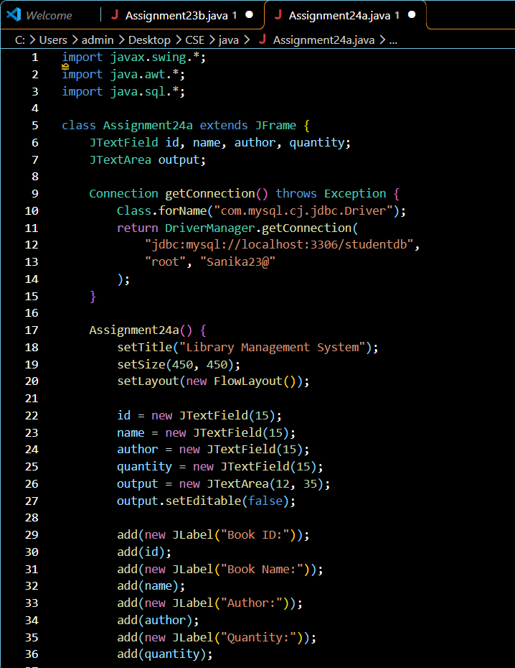
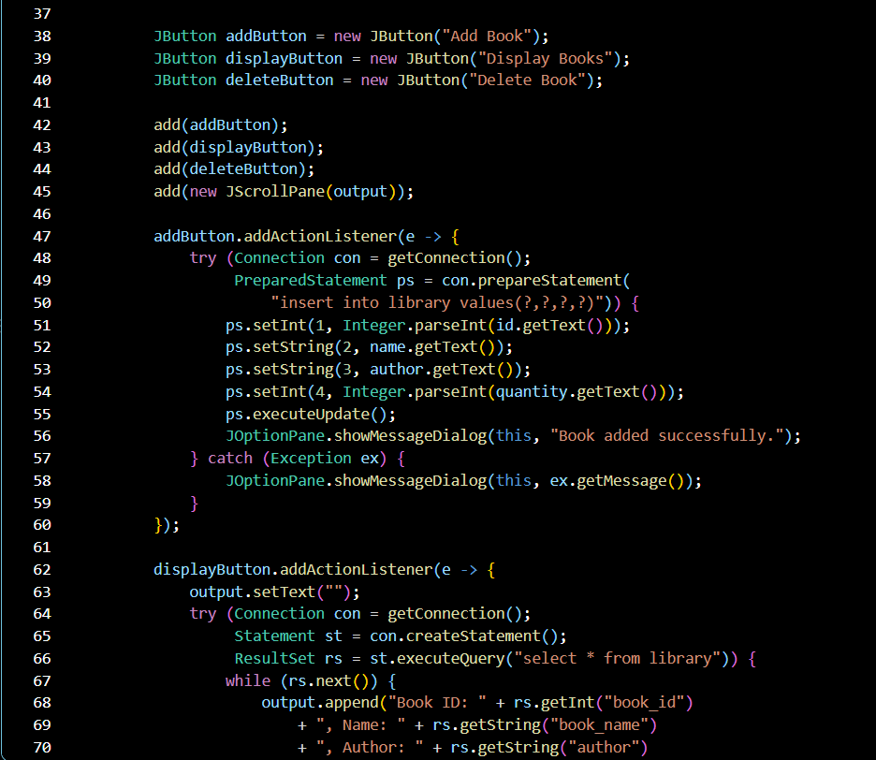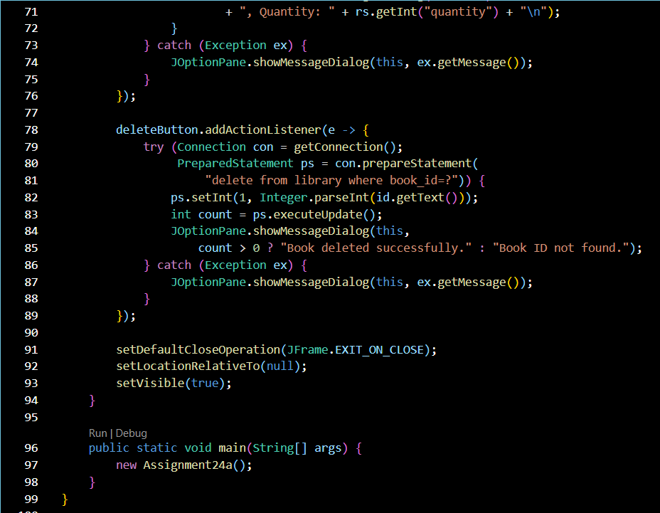
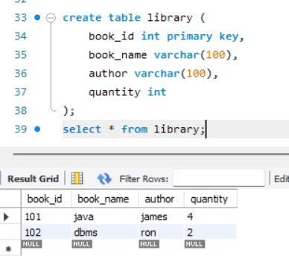

Output:

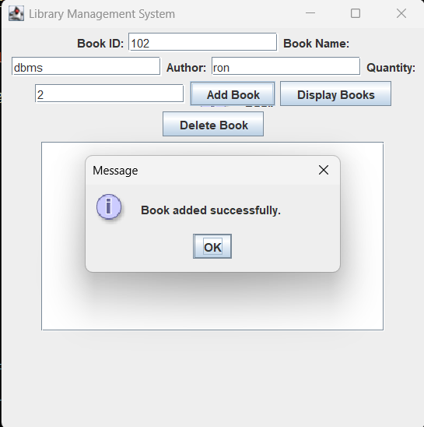
2. Create a Book Issue Tracking System GUI application using Java Swing connected to a database. The system should store book ID, student name, issue date, and return date, and allow record management.
Code:
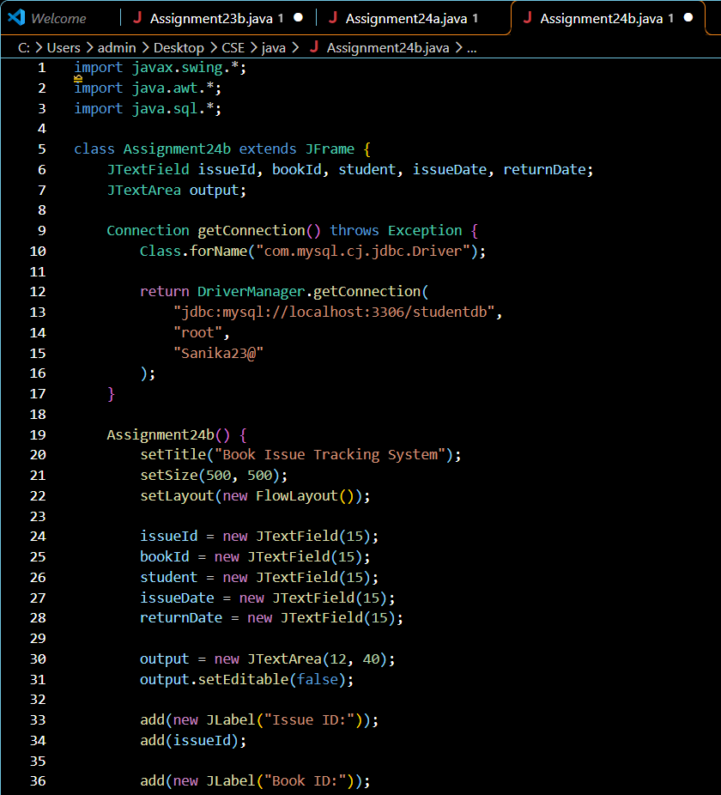
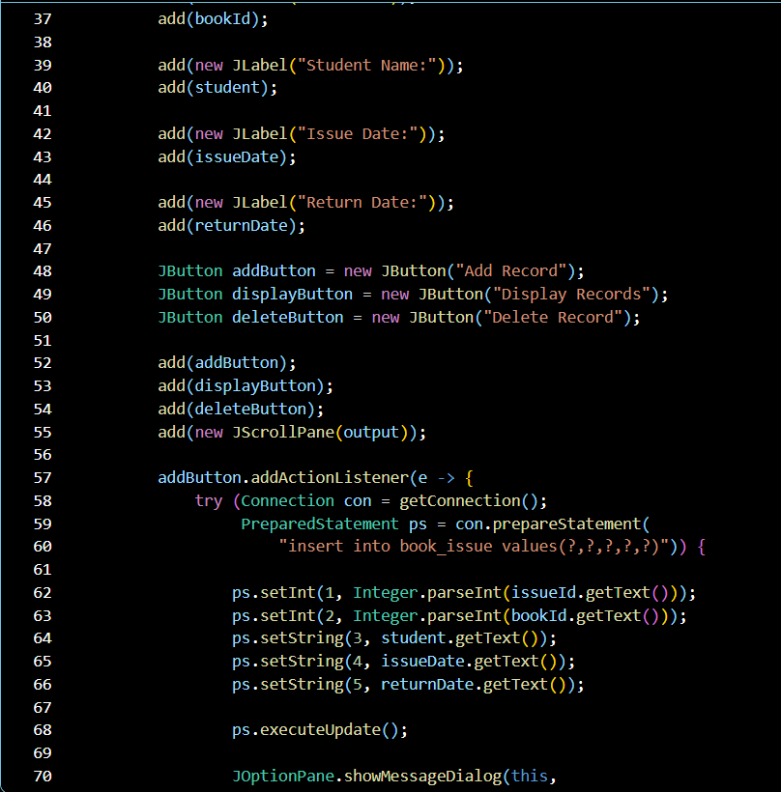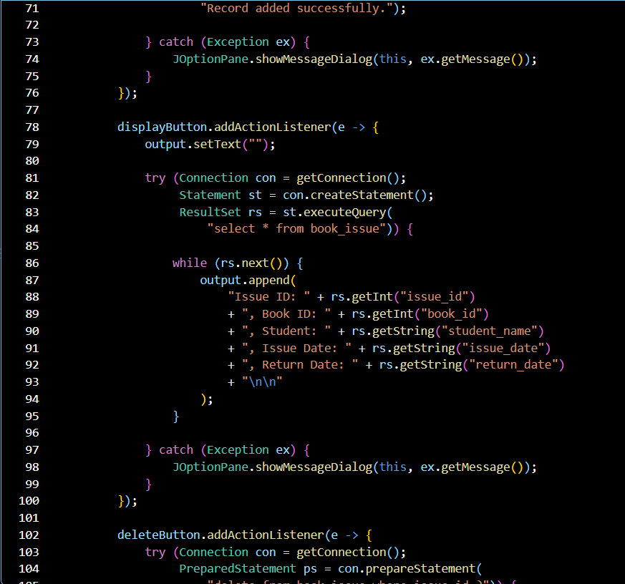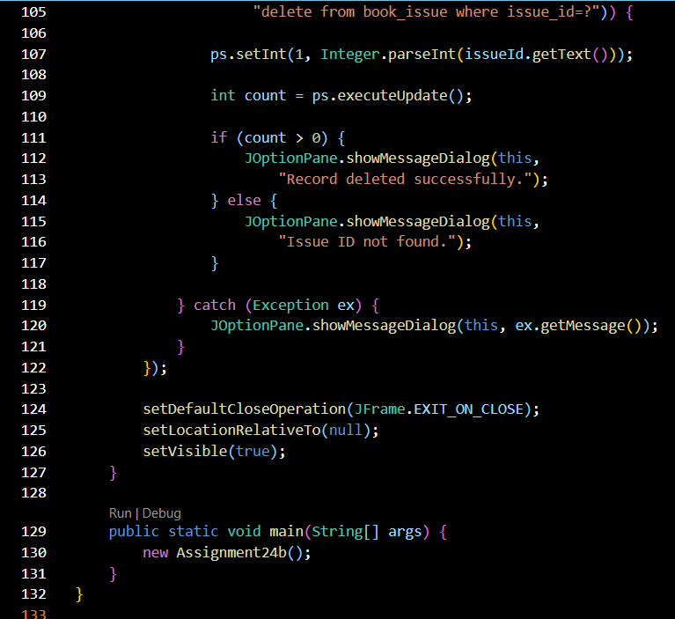

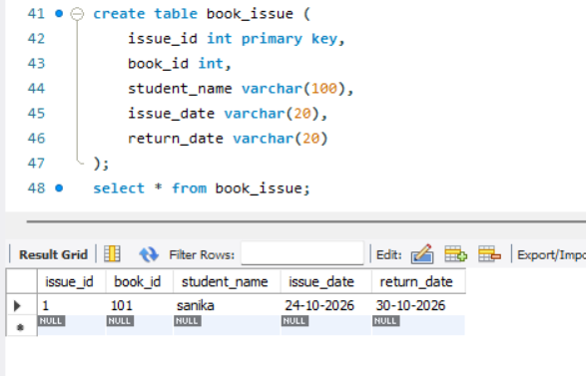
Output:

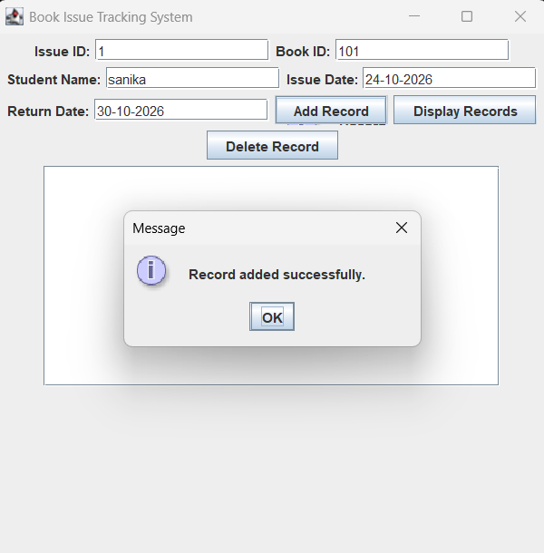
Conclusion
Thus, the Book Issue Tracking System was successfully developed using Java Swing and JDBC. The application allows users to add, display, and delete book issue records containing the issue ID, book ID, student name, issue date, and return date. This assignment helped in understanding GUI development, database connectivity, and CRUD operations using Java and MySQL.

